**SQL Server**

**1.Extracting Year,Month using Group and order by Year,Month**

SELECT

YEAR(order_a.[Order Date]) AS order_year,

MONTH(order_a.[Order Date]) AS order_month,

SUM(order_a.Sales) AS revenue,

COUNT(DISTINCT order_a.[Order ID]) AS volume

FROM

dbo.Orders$ AS order_a

WHERE

order_a.[Order Date] BETWEEN '2014-01-01' AND '2015-12-31'

GROUP BY

YEAR(order_a.[Order Date]),

MONTH(order_a.[Order Date])

ORDER BY

order_year,

order_month;

**Output:**

|  |  |  |  |
| --- | --- | --- | --- |
| order_year | order_month | revenue | volume |
| 2014 | 1 | 241268.6 | 450 |
| 2014 | 2 | 184837.4 | 385 |
| 2014 | 3 | 263100.8 | 530 |
| 2014 | 4 | 242771.9 | 523 |
| 2014 | 5 | 288401 | 667 |
| 2014 | 6 | 401814.1 | 899 |
| 2014 | 7 | 258705.7 | 540 |
| 2014 | 8 | 456619.9 | 843 |
| 2014 | 9 | 481157.2 | 1017 |
| 2014 | 10 | 422766.6 | 810 |
| 2014 | 11 | 555279 | 1077 |
| 2014 | 12 | 503143.7 | 1093 |

**2.Using SUM()**

SELECT SUM("Sales") AS total_revenue

FROM dbo.Order$;

**Output:**

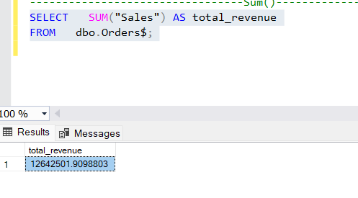

**3.Using Distinct()**

SELECT

COUNT(DISTINCT "Order ID") AS volume

FROM

dbo.Orders$;

**Output:**

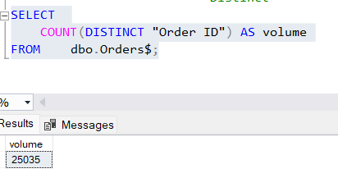

**4. Using Order by()**

SELECT "Customer ID", "Customer Name",Profit

FROM dbo.Orders$

ORDER BY Profit DESC ;

**Output:**

